Assgnment7
1. In each case below, say what language (a subset of {a, b}∗ ) is generated by the context-free grammar with the indicated productions.
a. S → aS | bS | #
b. S → SS | bS | a
c. S → SaS | b
d. S → TT
T → aT | T a | b
f. S → aSa | bSb | aAb | bAa
A → aAa | bAb | a | b | #
2. In each case below, find a CFG generating the given language.
a. The set of odd-length strings in {a, b} ∗ with middle symbol a.
b. The set of even-length strings in {a, b}∗ with the two middle symbols
equal.
c. The set of odd-length strings in {a, b} ∗ whose first, middle, and last
symbols are all the same.

3. Describe the language generated by the CFG with productions
S → ST | #
T → aS | bT | b
Give an induction proof that your answer is correct.

4. Find context-free grammars generating each of the languages below.
a. {a i bj | i ≤ j }
b. {a i bj | i < j }
5. Let L be the language generated by the CFG with productions
S → aSb | ab | SS
Show that no string in L begins with abb.
6. Draw an NFA (which might be an FA) accepting the language generated by the CFG having the given productions.
S → aA | bC
A → aS | bB
B → aC | bA
C → aB | bS | #

7. Show that the CFG with productions
S → a | Sa | bSS | SSb | SbS
is ambiguous.

7. Wrte the Regular grammar corresppondng to the FA.
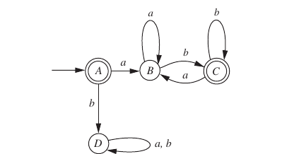

8. Consider the C statements
x = 1; if (a > 2) if (a > 4) x = 2; else x = 3;

a. What is the resulting value of x if these statements are interpreted
according to the derivation tree in Figure 4.21a and a = 3?
b. Same question as in (a), but when a = 1.
c. What is the resulting value of x if these statements are interpreted
according to the derivation tree in Figure 4.21b and a = 3?
d. Same question as in (c), but when a = 1.

